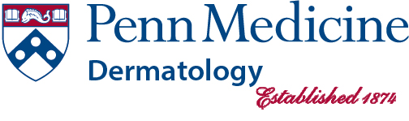

The Children’s Hospital of Philadelphia (CHOP) Section of Dermatology and Penn Medicine’s Department of Dermatology at the University of Pennsylvania proudly join together in leading the combined PGY 1-4 Pediatric Dermatology focused residency track.

This track includes a PGY 1 pediatric internship year at CHOP, and PGY 2-4
dermatology residency position (with dedicated time to pediatric dermatology training
throughout the 3-year dermatology residency, including development of a pediatric
dermatology outpatient continuity clinic starting as early as PGY 1 year).

Strong candidates who are committed to a career in pediatric dermatology are encouraged to apply for this unique opportunity, which requires a combined match. The preliminary pediatric year will include regular pediatric dermatology outpatient clinic exposure. The dermatology residency years will involve a pediatric dermatology continuity clinic throughout. Graduates of the program will be expected to board certify in General Dermatology (and will not be board eligible for Pediatrics as a result of this program; if that is of interest, completion of a full pediatrics residency is recommended).

Interviews will occur over a one-day schedule and will include coordinated interviews with both the CHOP Pediatric Residency Directors and Penn Dermatology Faculty.

Applications will be handled through the Department of Dermatology. For more information, please see our website: https://dermatology.upenn.edu/residents/residency-tracks/

Please pay close attention to ERAS / NRMP details regarding this and other tracks.

If interested or have any additional questions, please contact:
Barbara Lang
Dermatology Residency Program Coordinator
Department of Dermatology
University of Pennsylvania
DRA@uphs.upenn.edu

We look forward to hearing from qualified applicants this Fall.

Thank you, and good luck.

