UNIVERSITY OF PENNSYLVANIA
Dermatopathology Fellowship Program

Program(s):
The goal of this fully approved program is training and certification in dermatopathology that will produce future leaders in clinical or academic practice. One or two years are offered that encompass comprehensive exposure to diagnostic dermatopathology, immunodermatology, correlative clinical dermatology, and research. Physical and administrative location of the Dermatopathology Division in the Department of Dermatology affords routine clinical/patient interaction. Opportunities to interface with members of the Pathology Department are integral to the program. Exposure to immunofluorescence microscopy, immunohistochemistry, specialized microscopy, and diagnostic molecular biology is offered. Fellows assume teaching responsibilities at the residency, staff, and postgraduate levels. Areas of specialized faculty expertise include malignant melanoma, cutaneous lymphoma, psoriasis, bullous disorders, cutaneous manifestations of immunodeficiency states, nail disorders, infectious diseases, and alopecia.

Requirements: Board-eligible/Board-certified in Dermatology or Anatomic Pathology.

Types and Numbers of Appointments:
Two ACGME accredited fellowship appointments are available. Training may be also offered or extended based upon postdoctoral collaborative research interactions at either the Hospital of the University of Pennsylvania or the University of Pennsylvania School of Medicine.

Facilities:
The University of Pennsylvania, founded in 1740, gave rise to the nation's first medical school, and the Hospital of the University of Pennsylvania ("HUP") was the first teaching hospital in America. The Division of Dermatopathology has a very active primary and consultative practice for provision of specimens for fellowship training. The Dermatopathology group is located in the main hospital (HUP west), fostering interactions with Dermatology and Pathology faculty, residents and medical students. The Department's Duhring Research Laboratories are centralized in the adjacent Biomedical Research Building, where investigations focused at skin stem cell biology, cutaneous immunology, lymphoma, keratinocyte differentiation, bullous disorders, and epidemiology are actively pursued by fellows and staff. The Medical School, Dermatology outpatient clinic, Medical Library, and associated facilities such as the Wistar Institute are within one block. The Division is completely computerized and equipped with Medline literature retrieval and Internet access. Frequent departmental lectures and visiting professorships foster interaction with clinicians and researchers of national and international repute.

Community:
In addition to the proximity of the Hospital-Medical Center Complex to the undergraduate and graduate facilities of the University and to the cultural resources of Philadelphia, a number of major attractions are within two hours by land. These include Washington DC, New York City, shore points, and mountain ranges to the west.

Stipends:
Fellowship stipends for PGY 5-6 level applicants range from approximately $83,041 to $86,534. A full fringe benefit package accompanies each yearly stipend.

Staff:
Emily Chu, MD, PhD Associate Professor of Dermatology; Program Director; Rosalie Elenitsas, MD Professor of Dermatology; Director of Penn Cutaneous Pathology Services; John T. Seykora, MD, PhD Professor of Dermatology; Associate Program Director; Carrie L. Kovarik, MD Professor of Dermatology; Faizan Alawi, DDS Professor of Pathology, School of Dental Medicine; Jina Chung, MD Assistant Professor of Clinical Dermatology; David E. Elder, MB, ChB Professor of Pathology; George Xu, MD, PhD Professor of Pathology; Eric Morgan MD, Assistant Professor of Clinical Pathology and Laboratory Medicine

Collaborators/Affiliated Staff
George Cotsarelis, MD skin stem cell biology; Joel Gelfand, MD, MSCE clinical trials, psoriasis; Michael Ming, MD melanocytic lesions, epidemiology; Ellen Kim, MD lymphoma; Victoria Werth, MD connective tissue & bullous disorders.

Applications:
Applications for the July 1st, 2026 - June 30th, 2027 fellowship will be accepted beginning July 1st, 2024. Applications and requirements can be submitted to our online form: Dermatopathology Fellowship Application for FY 2026-2027
and must be submitted on or before August 23rd, 2024.
Address Inquiries to:
Kristina DiGiacomo
Dermatopathology Fellowship Coordinator
University of Pennsylvania School of Medicine
2 Maloney Building - 3600 Spruce Street Philadelphia, PA 19104-4128
Phone: (215) 662-4497 Fax: (215) 662-7784 E-mail: Kristina.DiGiacomo@pennmedicine.upenn.edu

The Pavillion (HUP EAST)


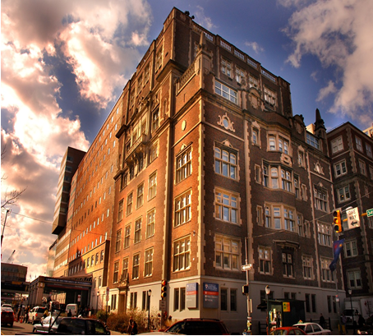 Main on Spruce (HUP WEST)

